Temporary Accommodation and
Build shelter for survivors of disasters (Sur-Turkey)
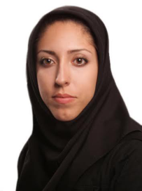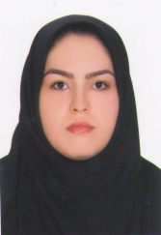 | Negar Javadi,Sara Khooshro  Institute of Seience Master of Architecture  Istanbul Aydın University , Florya /  Istanbul /Turkey Negar.javadi.n@gmail.com,Sara.khooshroo@gmail.com

ABSTRACT
Today, home and family have become one of the most important human needs, though living alone has become more common, humans still seek to have families and collective lives so that they can get relaxed with their family after a long time working during the day. But it would not be always like this. Sometimes family union changes in the way that the unity of family gets influenced by crisis and breaks up the way humans and families and its subgroups which again are those family members match and adjust and therefore people get into trouble in fulfilling their needs.

Unexpected accidents which are events that inevitably and surprisingly start to happen and because of their widespread influences on earther and human sources and also effect on natural process of living cut, they are out of society’s capacity of getting used to something and sometimes without international helps they become real human disasters. Even though Turkey is always in many environmental casualties like earthquakes, snow slides, forest conflagrations, floods and droughts. People usually knew earthquakes as an unexpected accident. But war itself is a part of these kinds of accidents which destroys living society and families. One of the difficulties that war causes is that makes the circumstance difficult for injured and homeless people. In these kinds of accidents losing shelter causes the loss of hope and human dissipation. So the first thing which brings trust back to people is to have shelter and gathering the family back.

One of the ways that reduces those problems is to study and present suitable ideas of temporary pre-built accommodation with a suitable method adjusted to international standards. The purpose of this contest is to study and recognize the exact need of accommodations and to respond people’s needs facing the crisis. The contest needs to introduce the capabilities that architecting with paper has meanwhile tries to study the suitable quality of it in creating a temporary place and also experiencing the methods of paper use in accommodating injured people. Using paper in building a temporary shelter after an accident is one of the modernist and good way for building a temporary accommodation both in costs and time.

KEY WORDS : Temporary accommodations, shelter, injured, natural casualties, paper in temporary accommodation .

